A000-Afr-Dem. Rep. Congo-Lulua-Chief's Wife

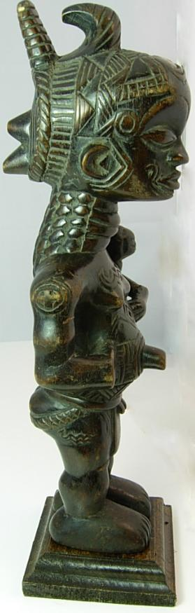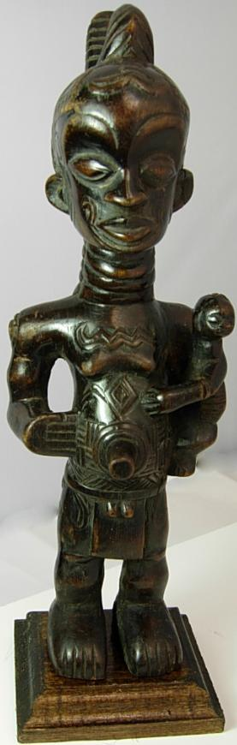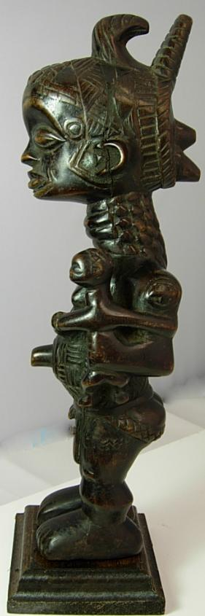

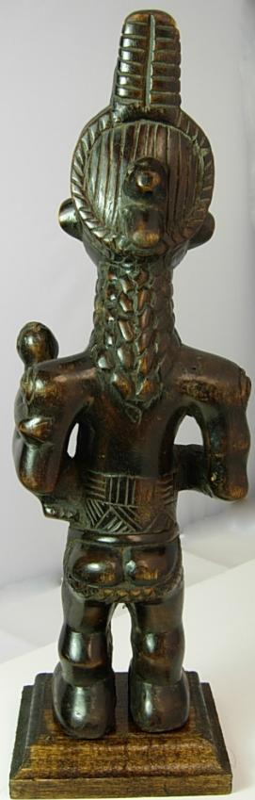

Case No.: 6

**Accession No.**

**Formal Label:**

**Display Description:**

Chief's Wife: Bena Lulua Ceremonial Chief's Wife Figure

This very rare female figure of a Chief's Wife with her child has excellent patina. Small hair line crack on the left side of the chest area and left side of the face was repaired with ebony wood filler, barely noticeable. Secured on a wooden base. This outstanding figure has excellent patina, measures 25 1/2" in height by 6" at width. Lulua arts are highly prized in the international collectors market. Lulua carved wood figures are identified by their distinctive and extensive curvilinear scarification patterns unique to each chieftancy, a manifestation of their individual tribal social differentiatiation. Since scarification was outlawed by the Belgian Colonial Government in the 1880's, the detail of the scarifications on this figure suggests that it was made in the early 19th or late 18th century.

The Lulua people (var. Luluwa) are a Bantu-speaking ethnic group of the Lulua River valley in south central Kasai-Occidental province, bordered by the larger Luba state and the related Songye people and Chokwe people, with whom they share a very similar culture, history, and language. The name Lulua seems to have appeared in the last quarter of the 19th century. Van Zandijcke, a Belgian missionary, reported that until 1870 there was no agreed collective name for the Lulua, with each kinship group or chieftaincy identifying themselves independently. In the 1880's Belgian colonials and the Luba empire pressured these people to develop a collective Lulua identity. Previously these groups were ethnically Luba people outside the Luba (or Baluba) political structure. Georges Nzongola-Ntalaja, in his history of Congo, describes the history Lulua ethnicity as an invented ethnicity.

This statue represents the female role-model for a Lulua village, and would be planted in the ground to protect the children when the mother was absent. Lulua figures have large heads with wide foreheads, elongated necks, protruding navels and stout shortened legs. The navel is often pointed, surrounded by concentric circles that symbolize life. The role of the chief's wife was to ensure a stable home life in the village. Her child clinging to her right side symbolizes her matronly care for all the children of the village, and indeed the children of the village were considered to be the children of all the people and so all had responsibility to care for each and every offspring.

**LC Classification:**

**Date or Time Horizon:**

**Geographical Area:**

**Map:**

**GPS coordinates:**

**Cultural Affiliation:**

**Media:**

**Dimensions:** measures 13 1/2" in height by 4" at width

**Weight:**

**Condition:**

**Provenance:**

**Discussion:**

**References:**

Mabika Kalanda, *Baluba et Lulua : une ethnie à la recherche d'un nouvel équilibre*. Bruxelles: Éditions de Remarques congolaises, 1959; Georges Nzongola-Ntalaja. *The Congo from Leopold to Kabila: a people's history*. New York: Zed Books, 2002; Constantijn Petridis. *Art and power in the Central African Savanna: Luba, Songye, Chokwe, Luluwa*. Mercatorfonds, 2008.

**Appendix:**

**Details of Statue**

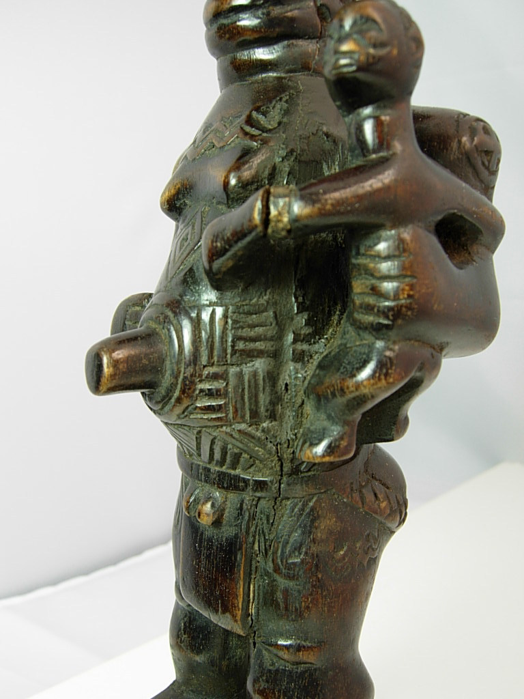 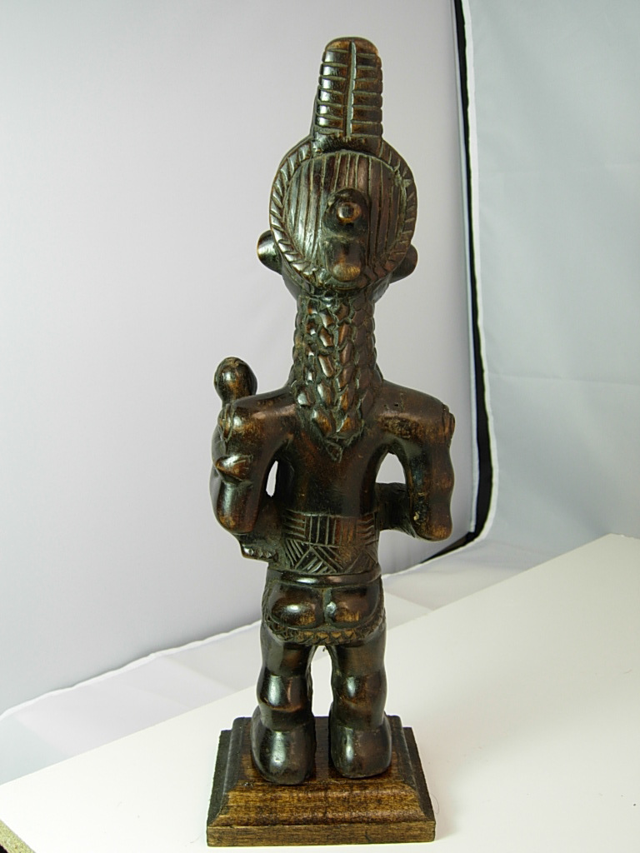 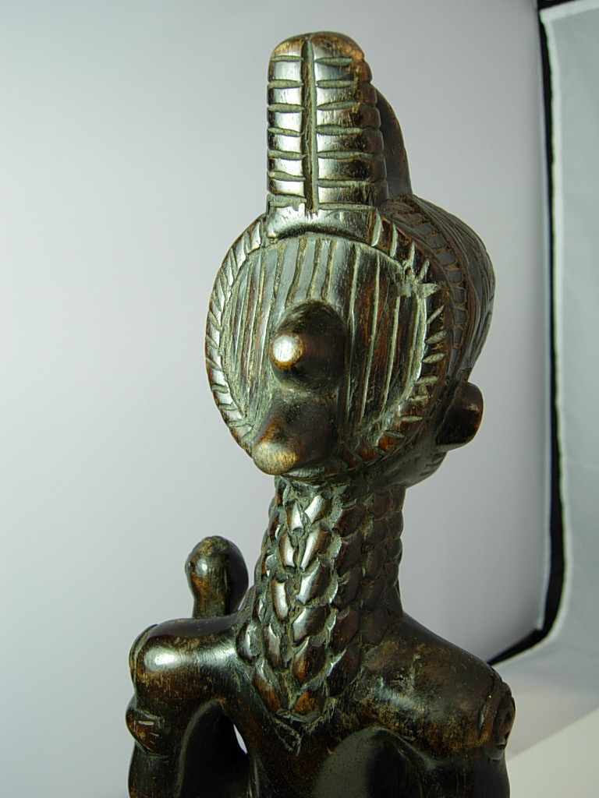 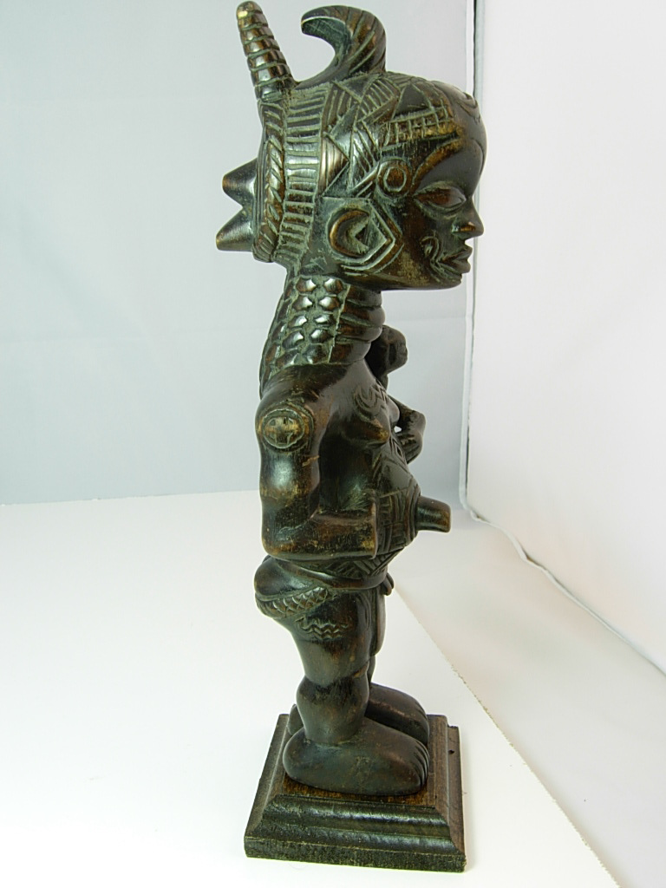 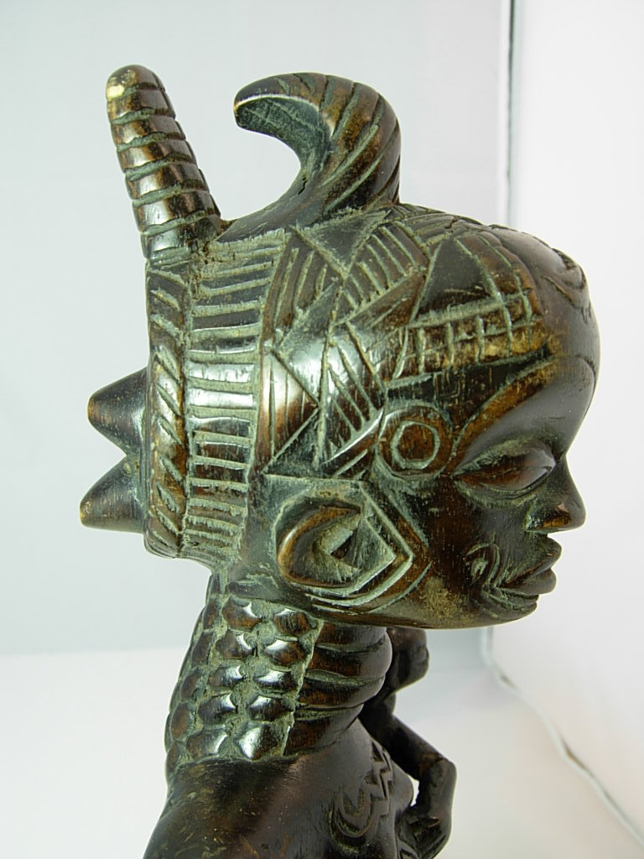 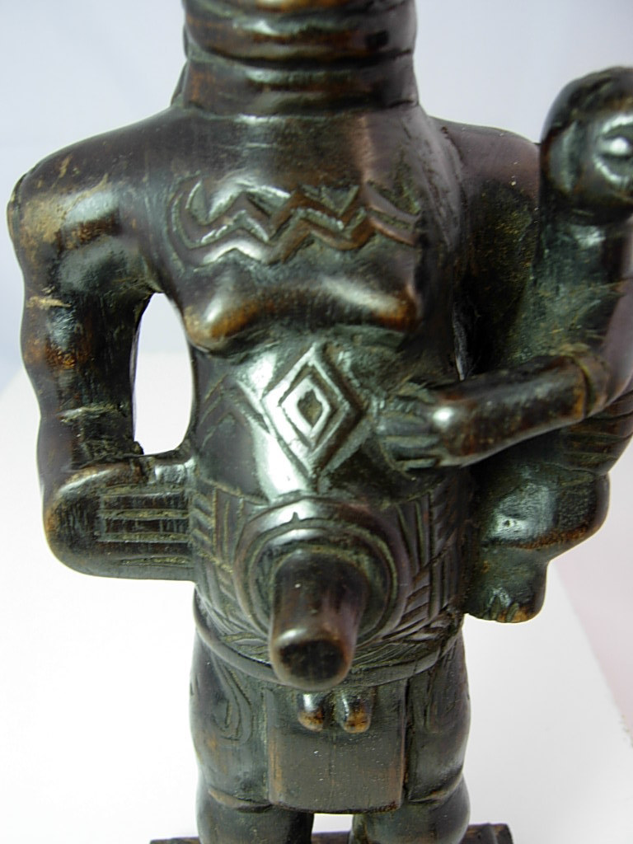 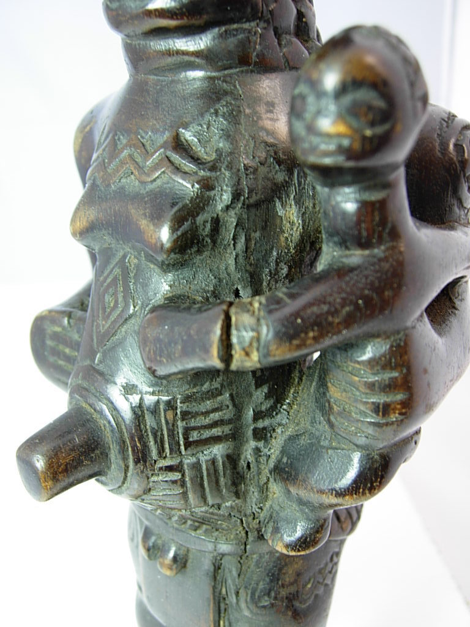

Bena Lulua Ceremonial Chief's Wife Figure

This very rare female figure of a Chief's Wife with her child has excellent patina, measures 13 1/2" in height by 4" at width. Small hair line crack on the left side of the chest area and left side of the face was repaired with ebony wood filler, barely noticeable. Secured on a wooden base. This outstanding figure has excellent patina, measures 25 1/2" in height by 6" at width. Lulua arts are highly prized in the international collectors market. Lulua carved wood figures are identified by their distinctive and extensive curvilinear scarification patterns unique to each chieftancy, a manifestation of their individual tribal social differentiatiation. Since scarification was outlawed by the Belgian Colonial Government in the 1880's, the detail of the scarifications on this figure suggests that it was made in the early 19th or late 18th century.

The Lulua people (var. Luluwa) are a Bantu-speaking ethnic group of the Lulua River valley in south central Kasai-Occidental province, bordered by the larger Luba state and the related Songye people and Chokwe people, with whom they share a very similar culture, history, and language. The name Lulua seems to have appeared in the last quarter of the 19th century. Van Zandijcke, a Belgian missionary, reported that until 1870 there was no agreed collective name for the Lulua, with each kinship group or chieftaincy identifying themselves independently. In the 1880's Belgian colonials and the Luba empire pressured these people to develop a collective Lulua identity. Previously these groups were ethnically Luba people outside the Luba (or Baluba) political structure. Georges Nzongola-Ntalaja, in his history of Congo, describes the history Lulua ethnicity as an invented ethnicity.

This statue represents the female role-model for a Lulua village, and would be planted in the ground to protect the children when the mother was absent. Lulua figures have large heads with wide foreheads, elongated necks, protruding navels and stout shortened legs. The navel is often pointed, surrounded by concentric circles that symbolize life. The role of the cief's wife was to ensure a stable home life in the village. Her child clinging to her right side symbolizes her matronly care for all the children of the village, and indeed the children of the village were considered to be the children of all the people and so all had responsibility to care for each and every offspring.

References: Mabika Kalanda, *Baluba et Lulua : une ethnie à la recherche d'un nouvel équilibre*. Bruxelles: Éditions de Remarques congolaises, 1959; Georges Nzongola-Ntalaja. *The Congo from Leopold to Kabila: a people's history*. New York: Zed Books, 2002; Constantijn Petridis. *Art and power in the Central African Savanna: Luba, Songye, Chokwe, Luluwa*. Mercatorfonds, 2008.

CV350, P160.

